Level 0

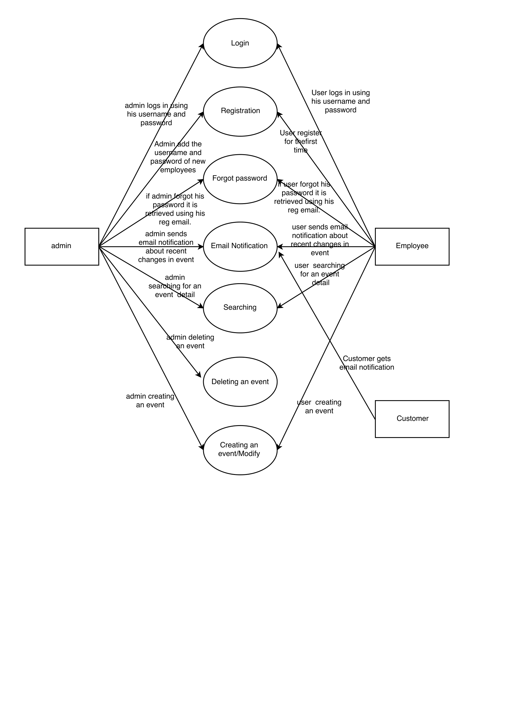

Level 1

Login

login.png

Registration

registration.png

Forgot Password

forgot_password.png

Searching

searching.png

Event Creation

event creation.png

Email Notification

email_notification.png

Deleting an Event

deleting an event.png